Library Management System (Backend)
Node.js | PostgreSQL | Sequelize

Features:
- Node.js + Express backend using Sequelize (Postgres).
- Main features: CRUD for Users, Authors, Publishers, Categories, Books, BookCopies, BorrowRecords; book issue/return flows.
- Database: PostgreSQL (configured in Models, used primary keys and ENUMs for statuses/roles)
- Inputs: HTTP JSON requests to endpoints under /API with resource payloads.
- Outputs: JSON responses: newly created resource (201), object (200), errors with {error: message}.

Database relationships (ER summary)

Author (1) —< (N) Book
Publisher (1) —< (N) Book
Category (1) —< (N) Book
Book (1) —< (N) BookCopy
BookCopy (1) —< (N) BorrowRecord
User (1) —< (N) BorrowRecord

ER Diagram:
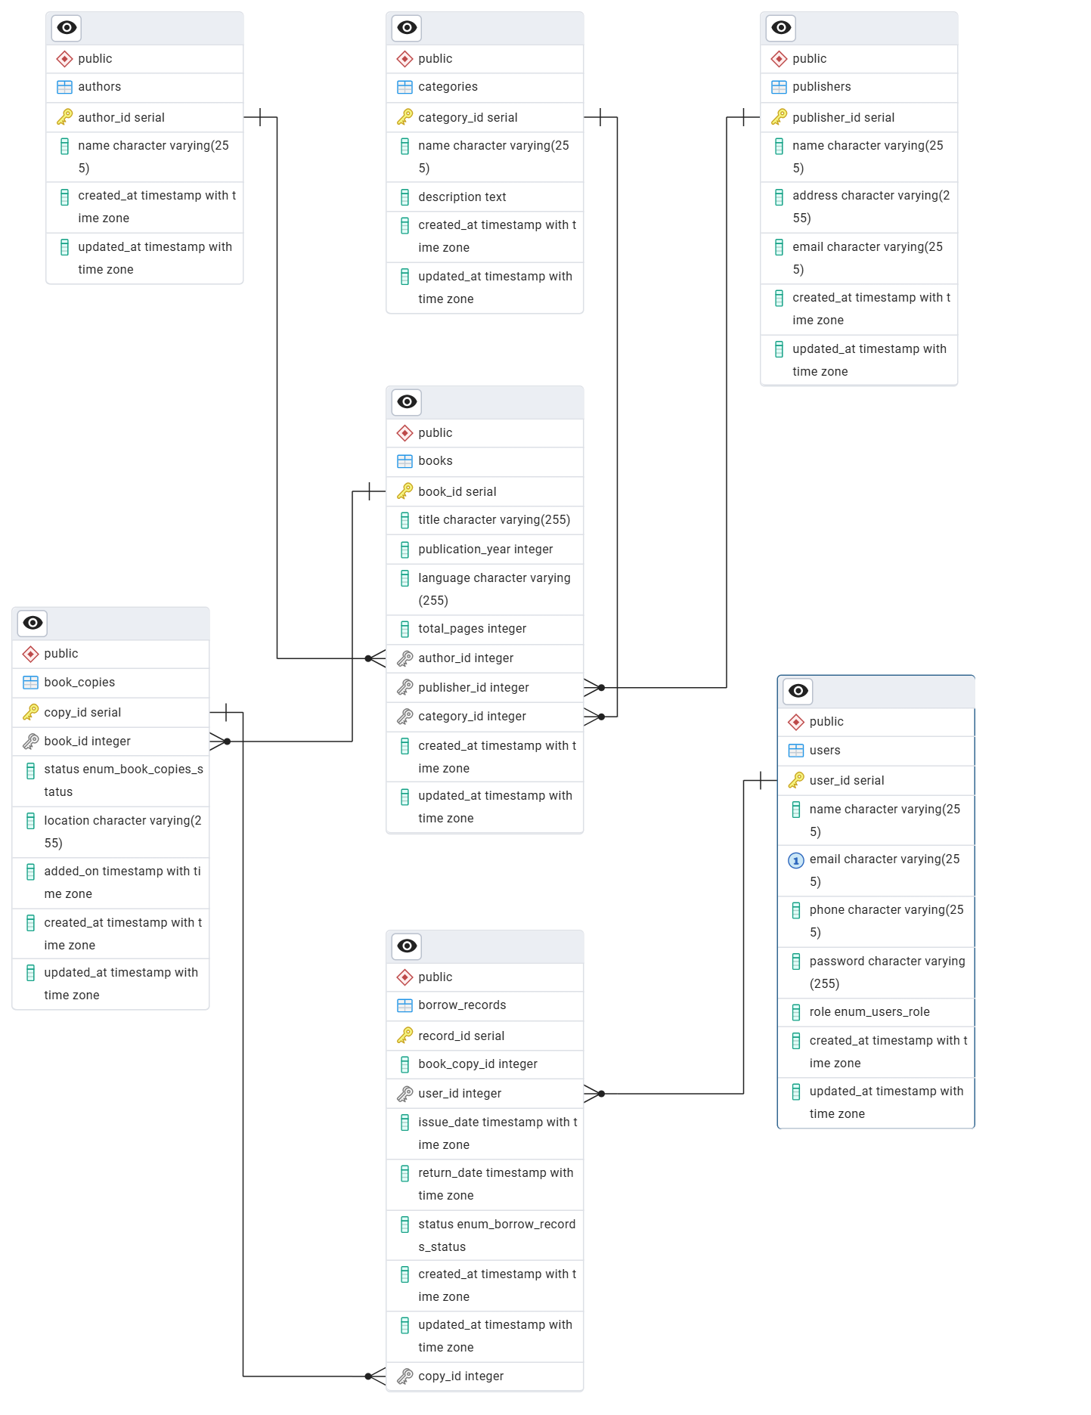
Models:
User: Stores user details (students, staff, or admins).
- user_id (PK)
- name (string, required)
- email (string, unique)
- phone (string)
- password (string, required)
- role (ENUM: 'member'|'admin')
- created_at (timestamp)
- updated_at (timestamp)
Author: Stores information about book authors.
- author_id (PK)
- name(string)
- created_at (timestamp)
- updated_at (timestamp)

Publisher: Holds details of publishing companies.
- publisher_id (PK)
- name (string)
- address (string)
- contact_email (string)
- created_at (timestamp)
- updated_at (timestamp)

Category: Classifies books by genre or subject.
- category_id (PK)
- name (string)
- description (string)
- created_at (timestamp)
- updated_at (timestamp)

Book: Stores book-level metadata (not individual copies).
- book_id (PK)
- title (string, required)
- publication_year (integer)
- language (string)
- total_pages (integer)
- author_id (FK --> Author)
- publisher_id (FK --> Publisher)
- category_id (FK --> Category)
- created_at (timestamp)
- updated_at (timestamp)

BookCopy: Represents physical copies of each book.
- copy_id (PK)
- book_id (FK --> Book)
- status (ENUM: 'available','issued','lost')
- location (string)
- added_on (date)
- created_at (timestamp)
- updated_at (timestamp)

BorrowRecord: Tracks book issuance and return details.
- record_id (PK)
- user_id (FK --> User)
- copy_id (FK --> BookCopy)
- issue_date (date)
- due_date (date)
- return_date (date)
- status (ENUM: 'issued','returned','overdue')
- created_at (timestamp)
- updated_at (timestamp)

Index.js: wires associations.
- Author/Publisher/Category -> Book (1:N)
- Book -> BookCopy (1:N)
- User -> BorrowRecord (1:N)
- BookCopy -> BorrowRecord (1:N)

